Propaganda during the WWII
Propaganda during the WWII | Difficulty
Propaganda during the WWII | 3

Name︰_______________ （ ） Class︰__________

Historical skill | Interpretating propagandas
Related Textbook Content | 3A pp. 64-66

Study the source below and answer the following questions.

Source A A cartoon published in Britain in 1909, entitled ‘No Limit’
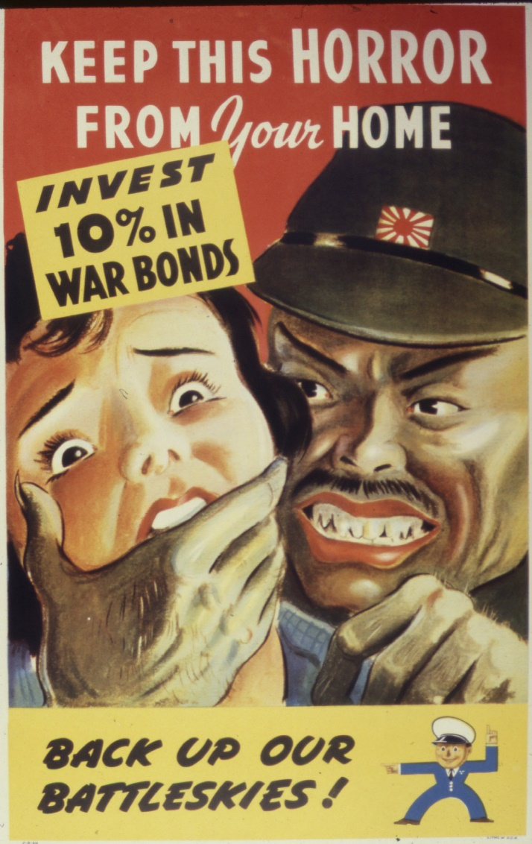
1) With reference to Source A, complete the following content.
- Publishing year: _____________, which means during ____________________
- Publishing country: _____________
- Figures in the cartoon representing the country: the person on the left represents _______________, the right represents ________________.

2) Describe the facial expressions and actions of the two figures in Source A.
The woman on the left was ________________ by the man on the right, showing a ________________ expression, while the man on the right showed a ________________ expression.

3) What attitude does the cartoonist of Source A express towards the country represented by the male figure in the cartoon? (add )
Respect
Antagonistic
Hatred
Trust

4) Based on your own knowledge, explain the reason for the cartoonist of Source A to have the attitude mentioned in Q(3).
Tips: Pay attention to the publishing year and the US-Japan relations at the time.

________________________________________________________________________
________________________________________________________________________
5) In your opinion, what was the purpose for publishing the propaganda of Source A? Explain your answer.
Tips: (1) What impression did the figures of the propaganda poster portray among the American public?
(2) Pay attention to the words in the propaganda.

________________________________________________________________________
________________________________________________________________________
________________________________________________________________________
________________________________________________________________________

Answers

1)
- Publishing year: _____1942____, which means during _____ Second World War____
- Publishing country: ____the US_____
- Figures in the cartoon representing the country: the person on the left represents ____the US_____, the right represents _____Japan_____.

2) The woman on the left was _____being choked_____ by the man on the right, showing a ______scared_____ expression, while the man on the right showed a ____fierce___ expression.

3)
Respect
Antagonistic
Hatred
Trust

4) The propaganda was published in 1942, during WWII. Since Japan and the US was fighting in the Pacific War, the cartoonist, an American, expressed an antagonistic and hatred attitude towards Japan.

5) The cartoonist of Source A depicted Japan as a ruthless invader to arouse the anger and patriotic feelings of the American public. Moreover, the propaganda mentioned that ‘invest 10% in war bonds’ and ‘back up our battleskies’. This shows that the purpose of publishing the poster was to mobilise the American public to purchase war bonds in order to support the US on war against Japan.

